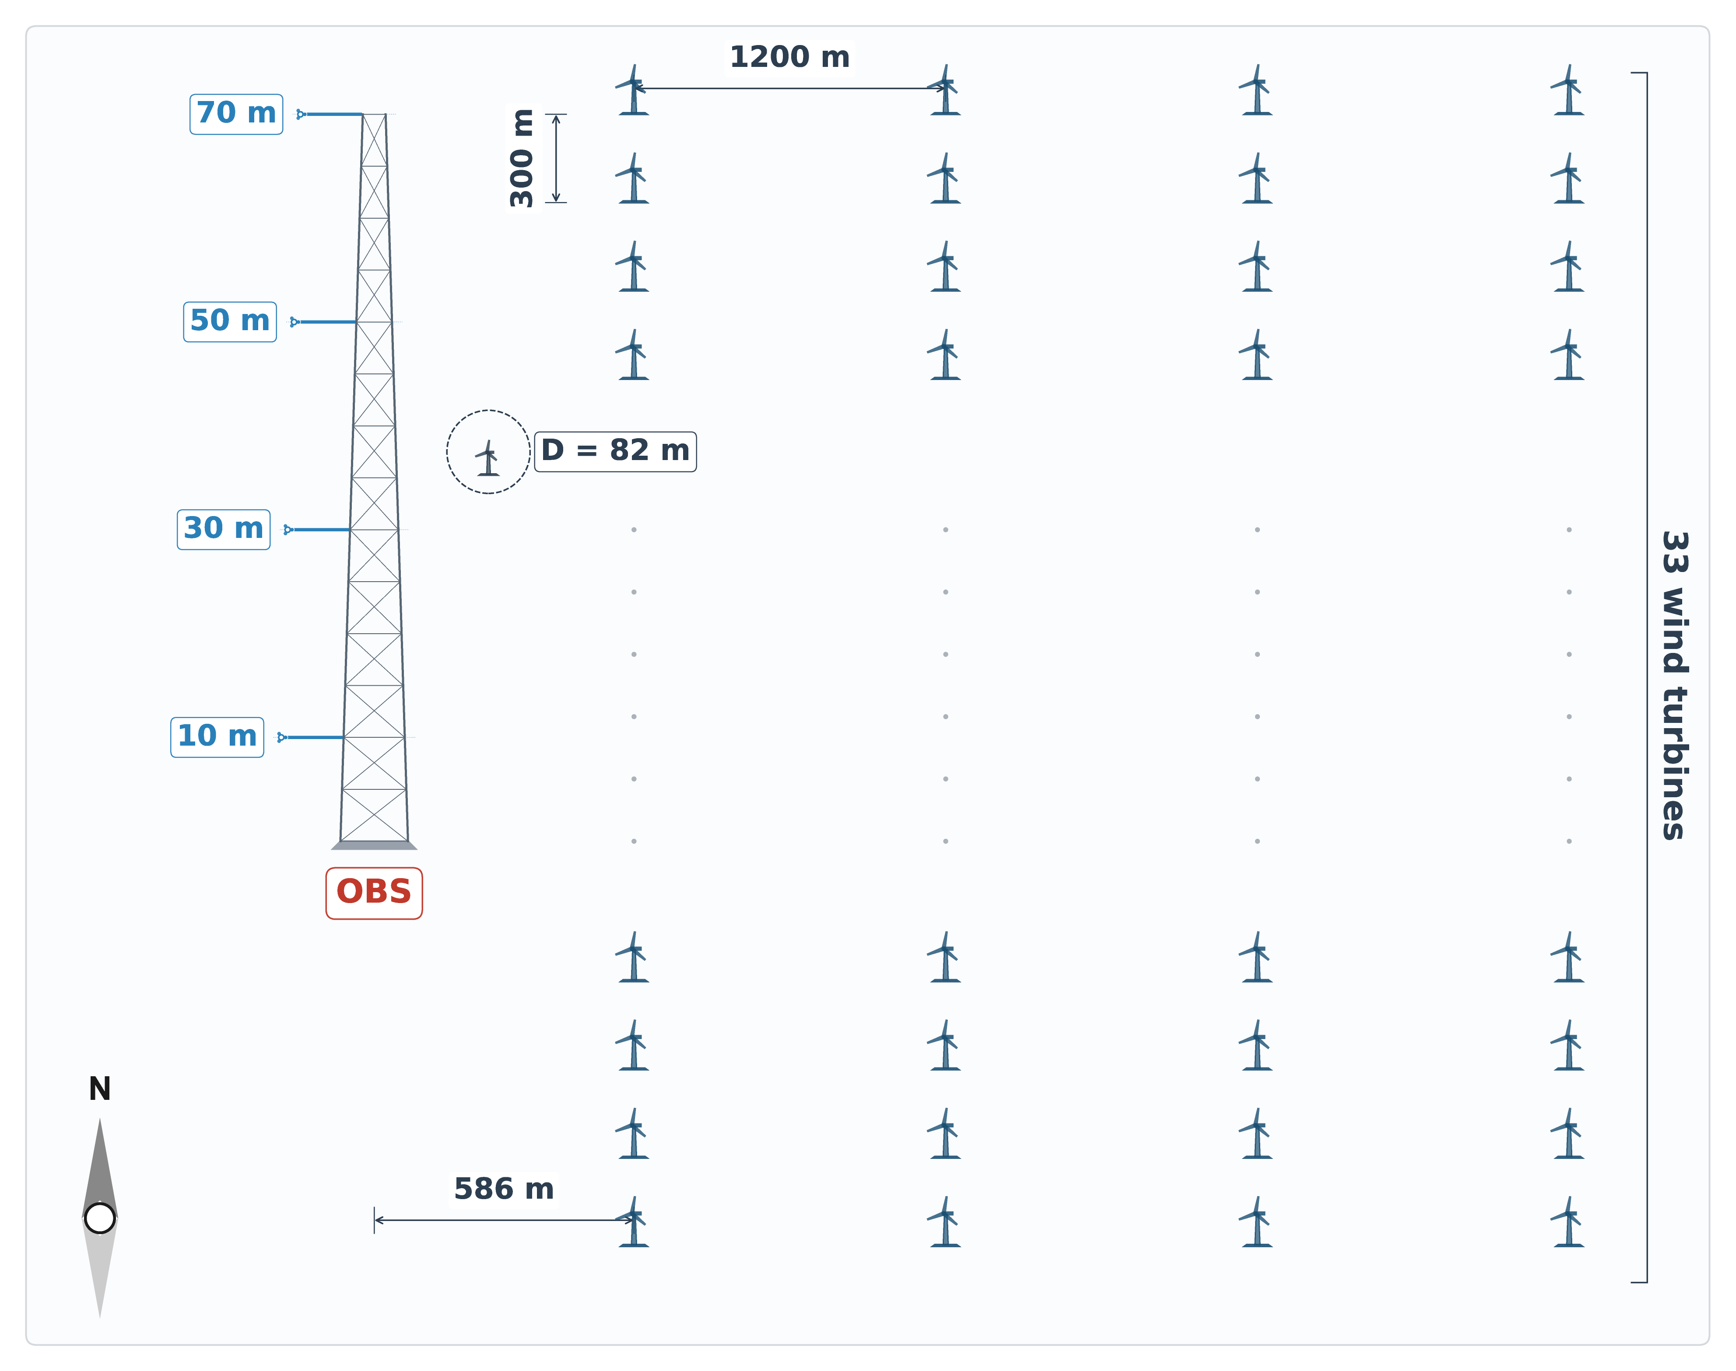

Figure 1. Schematic of the wind farm layout and meteorological mast configuration. The 70-m observation mast (OBS) is located 586 m west of the first turbine column. Wind speed and direction are measured at four heights (10 m, 30 m, 50 m, and 70 m). The farm comprises 134 turbines (33 rows × 4 columns, plus 2 additional turbines) with approximately 300-m row spacing and 1200-m column spacing. Each turbine has a rotor diameter (D) of 82 m and a hub height of 61.5 m. Westerly winds (from left) represent free-stream conditions at the mast, whereas easterly winds (from right) traverse the turbine array before reaching the mast, corresponding to wake-influenced conditions.

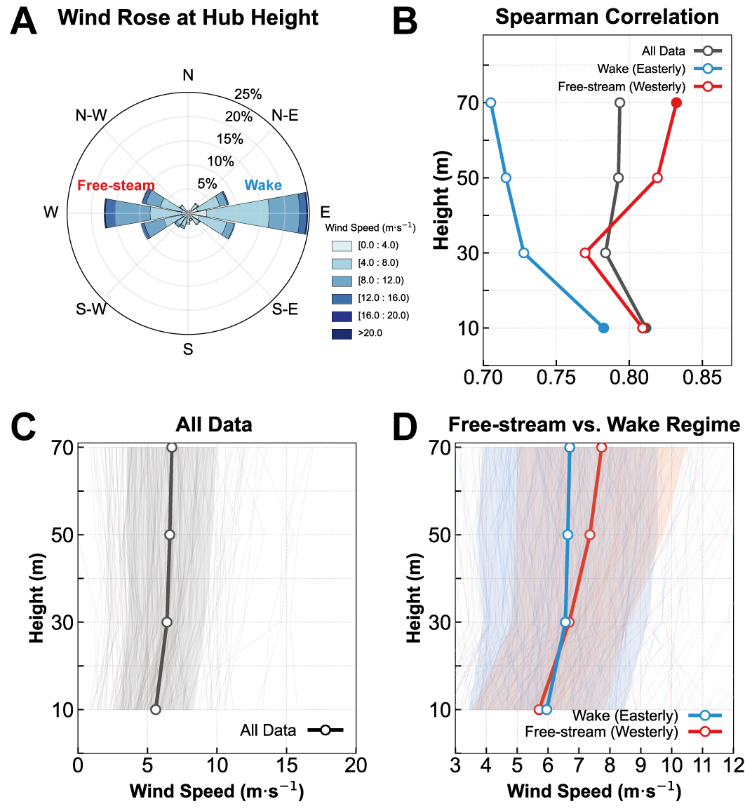

Figure 2. Regime-dependent vertical structure of wind speed and correlation with power production. A: Wind rose at 70-m hub height. The meteorological mast location 586 m west of the first turbine column (33 turbines) enables categorization into westerly free-stream and easterly wake effect sectors. B: Vertical profiles of Spearman correlation between height-specific wind speed and total power output for aggregate dataset (black), free-stream sector (red), and wake effect sector (blue). C: Mean vertical wind speed profile for the entire observation period with background thin lines representing individual instantaneous profiles and gray shading representing one standard deviation (±1σ). D: Comparison of mean vertical wind speed profiles between free-stream (red) and wake effect (blue) regimes with background thin lines showing individual profiles for each regime. Shaded areas denote one standard deviation (±1σ).

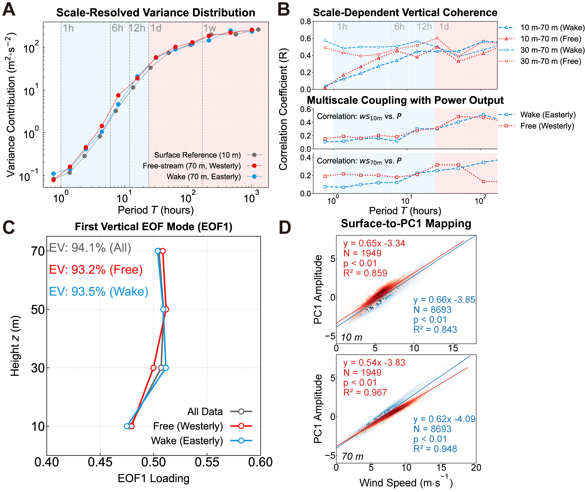

Figure 3. Scale-resolved variance distribution, vertical coherence, and linear relationship between surface wind and vertical profile energy state. A: Scale-resolved variance contribution of wind speed at 10 m (gray) and 70 m for free-stream (red) and wake effect (blue) conditions. Vertical dashed lines indicate temporal periods of 1h, 6h, 12h, 1d, and 1w. B: Scale-dependent vertical coherence and correlation with power output. Top panel shows Spearman correlation coefficient between wind speeds at different height pairs (10-70 m, 30-70 m) as a function of time scale. Bottom panels show Spearman correlation between power output and wind speed at 10 m and 70 m across multiple time scales. Shaded regions differentiate high-frequency and synoptic-scale regimes. C: Vertical profiles of EOF1 loadings for aggregate dataset (gray), free-stream (red), and wake effect (blue) regimes. Explained variance (EV) for each regime is indicated. D: Linear regression between 10-m wind speed (top) or 70-m wind speed (bottom) and PC1 amplitude of the vertical wind profile. Regression statistics including coefficient of determination, sample size, and significance level are shown for free-stream (red) and wake effect (blue) conditions.

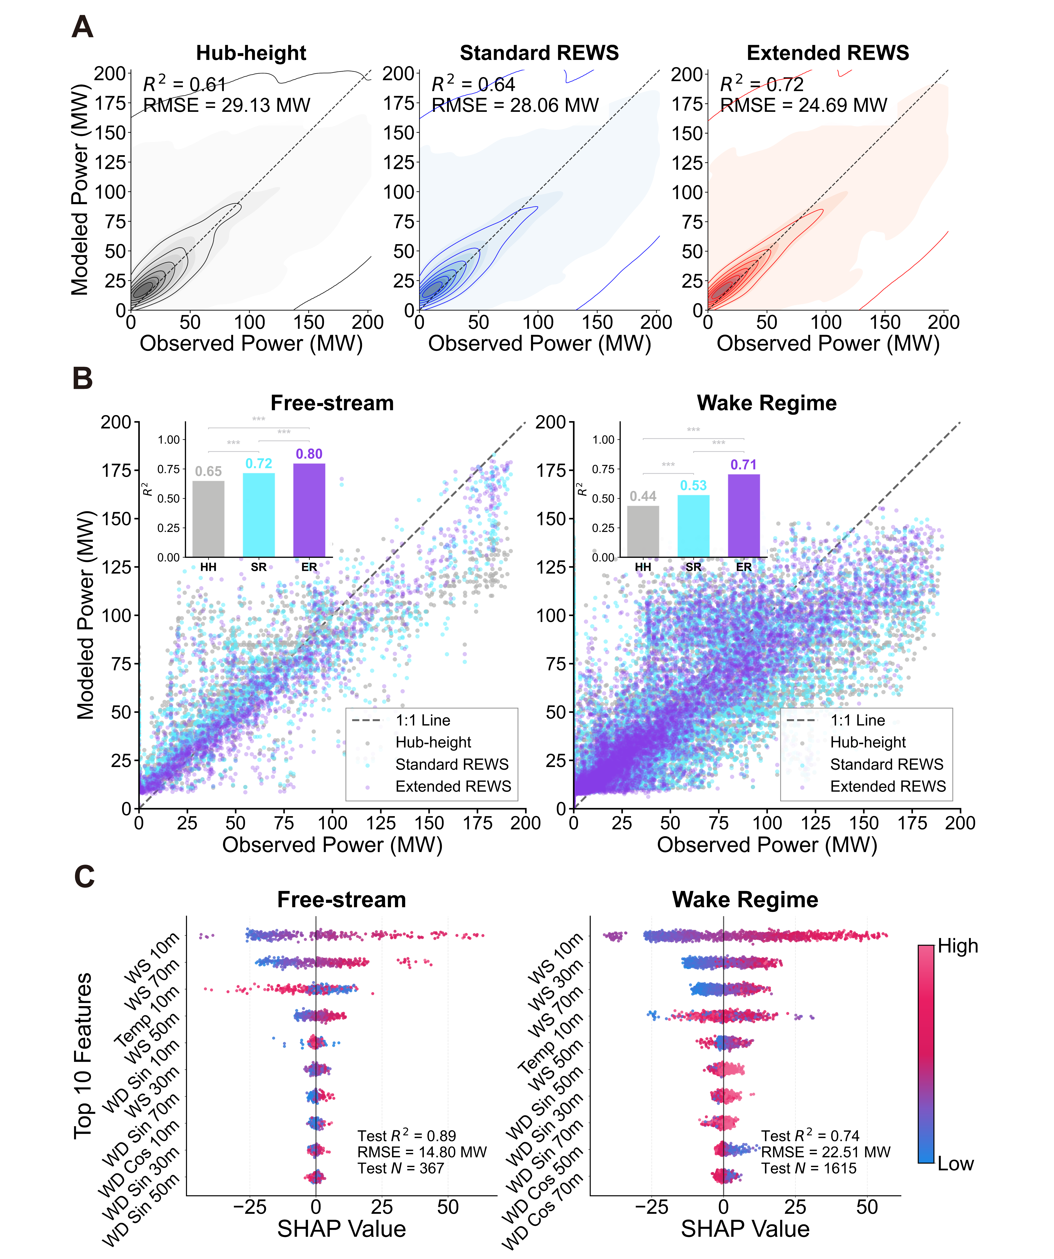

Figure 4. Comparative performance and feature importance analysis of power reconstruction frameworks. A: Density scatter plots comparing observed power with power reconstructed by LightGBM using three input configurations: Hub-height (HH), Standard REWS (SR), and Extended REWS (ER). Coefficient of determination and root-mean-square error are shown for each framework. B: Performance comparison across flow regimes showing coefficient of determination for the three frameworks under free-stream and wake effect conditions. Bar chart insets show significant performance improvement of ER over SR and HH based on Diebold-Mariano tests (***p < 0.01). C: SHAP analysis for the ER model under free-stream and wake effect regimes. Features are ranked by mean absolute SHAP value representing relative importance. Each point represents an individual sample with color indicating feature value magnitude and horizontal position showing impact on power prediction.

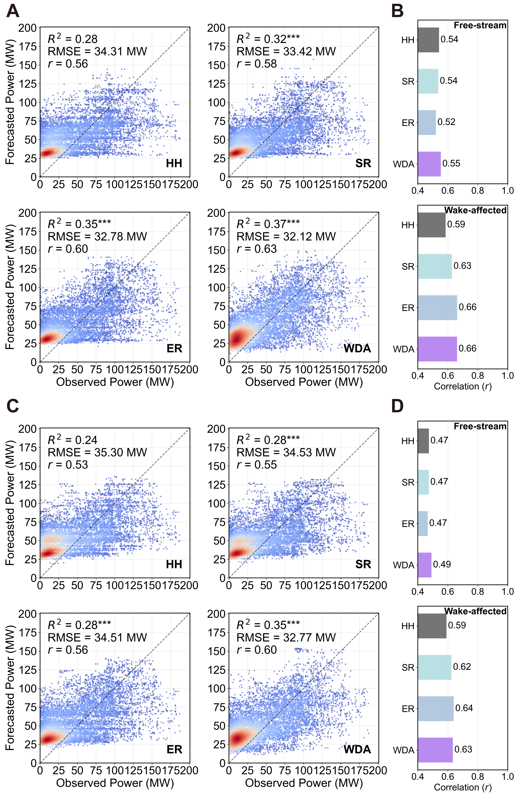

Figure 5. Operational evaluation of WDA strategy for day-ahead power forecasting. A and C: Density scatter plots comparing observed and forecasted power using four configurations: Hub-height (HH), Standard REWS (SR), Extended REWS (ER), and Wind-Direction-Aware (WDA). Results shown for A: EC-WRF and C: GFS-WRF driven forecasts on complete test dataset. Coefficient of determination, root-mean-square error, and correlation coefficient are shown for each configuration. Asterisks (***) indicate statistical significance at p < 0.01 level based on Diebold-Mariano tests relative to HH baseline. B and D: Correlation coefficients across free-stream and wake effect regimes for B: EC-WRF and D: GFS-WRF.

